Finland
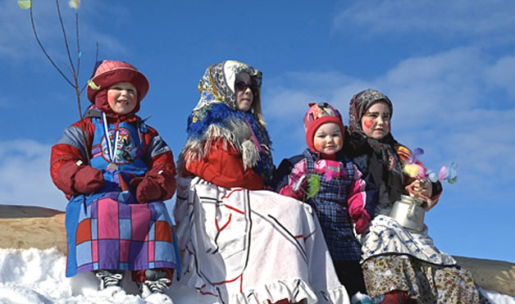
Children in this Scandinavian country go begging in the streets with sooty faces and scarves around their heads, carrying broomsticks, coffeepots and bunches of willow twigs. In some parts of Western Finland, people burn bonfires on Easter Sunday, a Nordic tradition stemming from the belief that the flames ward off witches who fly around on brooms between Good Friday and Easter Sunday.
Poland
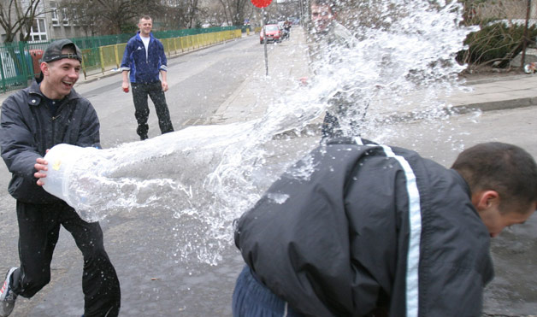
Pouring water on one another is a Polish Easter tradition called Smingus-Dyngus. On Easter Monday, boys try to drench other people with buckets of water, squirt guns or anything they can get their hands on. Legend says girls who get soaked will marry within the year. The refreshing tradition has its origins in the baptism of Polish Prince Mieszko on Easter Monday in 966 AD.
Haux, France
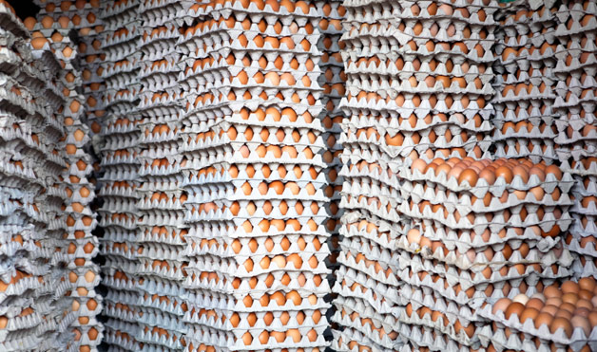
Don’t forget a fork if you’re in this southern French town on Easter Monday. Each year a giant omelet is served up in the town’s main square. And when we say giant, we mean giant: The omelet uses more than 4,500 eggs and feeds up to 1,000 people. The story goes, when Napoleon and his army were traveling through the south of France, they stopped in a small town and ate omelets. Napoleon liked his so much that he ordered the townspeople to gather their eggs and make a giant omelet for his army the next day.
Corfu, Greece
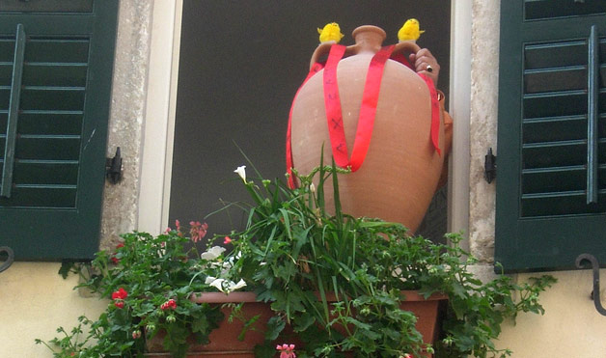
On the morning of Holy Saturday, the traditional “Pot Throwing” takes place on the Greek island of Corfu: People throw pots, pans and other earthenware out of their windows, smashing them on the street. Some say the custom derives from the Venetians, who on New Year’s Day used to throw out all of their old items. Others believe the throwing of the pots welcomes spring, symbolizing the new crops that will be gathered in the new pots.
Norway
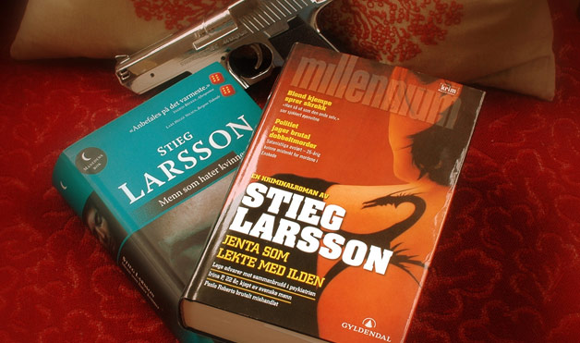
Easter is such a popular time for Norwegians to read crime novels that publishers actually come out with special “Easter Thrillers” known as Paaskekrimmen. The tradition is said to have started in 1923 when a book publisher promoted its new crime novel on the front pages of newspapers. The ads resembled news so much that people didn’t know it was a publicity stunt.
Rome, Italy
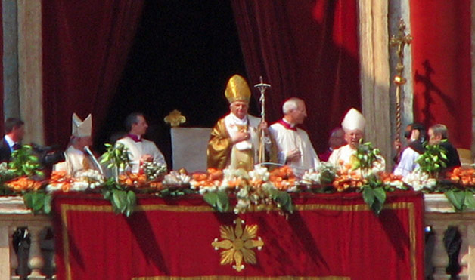
On Good Friday the Pope commemorates the Via Crucis (Way of the Cross) at the Colosseum: A huge cross with burning torches illuminates the sky as the 14 Stations of the Cross are described in several languages. Mass is celebrated on the evening of Holy Saturday, and on Easter Sunday, thousands of visitors congregate in St. Peter’s Square to await the Pope’s blessing from the church’s balcony, known as “Urbi et Orbi” (“To the City and to the World”).

Czech Republic and Slovakia
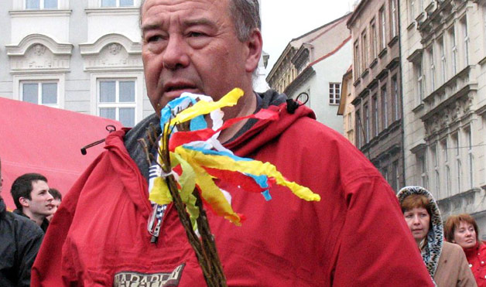
Traveling to these Eastern European countries over Easter? If so, you’d better watch your back! There’s an Easter Monday tradition in which men spank women with handmade whips made of willow and decorated with ribbons. According to legend, the willow is the first tree to bloom in the spring, so the branches are supposed to transfer the tree’s vitality and fertility to the women. This playful spanking is all in good fun and isn’t meant to cause pain.
Verges, Spain
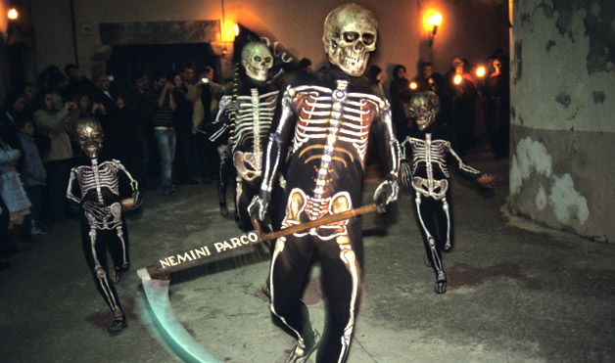
On Holy Thursday in the Medieval town of Verges, Spain, the traditional “dansa de la mort” or “death dance” is performed. To reenact scenes from The Passion, everyone dresses in skeleton costumes and parades through the streets. The procession ends with frightening skeletons carrying boxes of ashes. The macabre dance begins at midnight and continues for three hours into the early morning.

Washington, DC
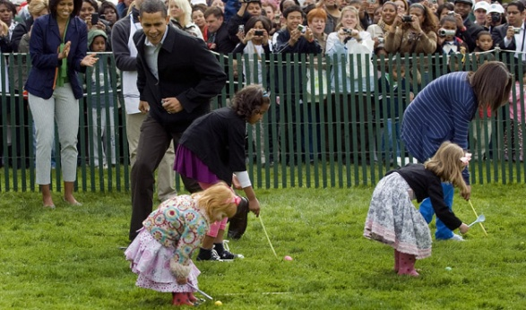
For 130 years, the White House has hosted the Easter Egg Roll on its South Lawn. The main activity involves rolling a colored hard-boiled egg with a large serving spoon, but now the event boasts many more amusements, like musical groups, an egg hunt, sports and crafts. This year’s theme is “Ready, Set, Go!” and will promote health and wellness, featuring activities that encourage children to lead healthy and active lives.

Hungary
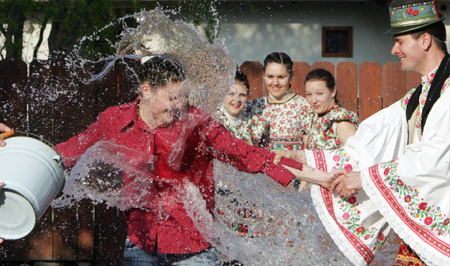
“Sprinkling,” a popular Hungarian Easter tradition, is observed on Easter Monday, which is also known as “Ducking Monday.” Boys playfully sprinkle perfume or perfumed water on girls. Young men used to pour buckets of water over young women's heads, but now they spray perfume, cologne or just plain water, and ask for a kiss. People used to believe that water had a cleaning, healing and fertility-inducing effect.

