
Write three words in each category! Name: _______________ Score:_______
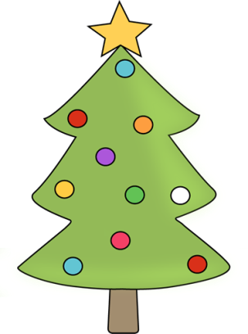
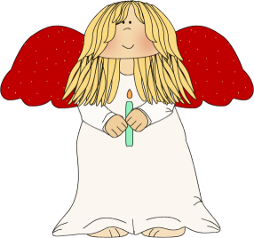
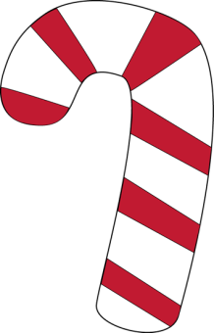
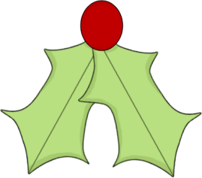
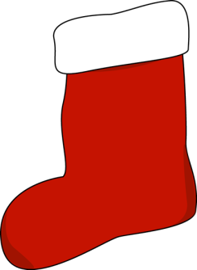

Three Christmas drinks
Three green Christmas decorations
Three of Santa’s reindeer
Three Christmas days
Three things on your christmas table
Three Christmas figures
Three Christmas presents
Three Christmas superstitions
Three things you eat at Christmas
Three Christmas movies
Three Christmas Carols
Three Christmas decorations
Three traditions at Christmas

