
*SANTA’S FREE TIME*
*What does Santa do in his free time?* Fill in the sentences with the correct form (Present Simple) of the appropriate verb and then number the pictures.
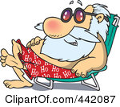
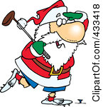

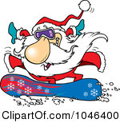
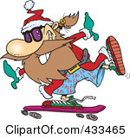
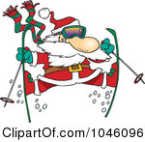
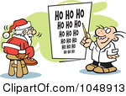
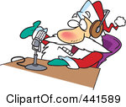

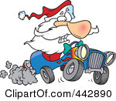
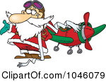

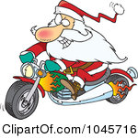

1

GO DO PLAY REPAIR SUNBATHE
EAT DANCE & SHAKE SURF RIDE
WORK TAKE LIKE WRITE TALK

- Santa usually ____plays___ golf with his elves.
- Santa often ____________ on the radio.
- Santa _____________ an eye exam in June.
- Santa sometimes _____________ as a pilot.
- Santa rarely _______________computers.
- Santa always ___________ skiing in Finland.
- Santa _____________ skateboarding in the morning.
- Santa ____________ e-mails on his computer.
- Santa ______________ on the beach twice a week.
- Santa __________ in a chair in the afternoons.
- Santa seldom ___________ the shopping by a snowboard.
- Santa ___________ his motorcycle at weekends.
- Santa _____________ by his truck three times a month.
14)Santa_____________________
maracas in Mexico.



created by dorkas
* key *
*SANTA’S FREE TIME*
*What does Santa do in his free time?* Fill in the sentences with the correct form (Present Simple) of the appropriate verb and then number the pictures.

- Santa usually ____plays___ golf with his elves.
2)Santa often ___talks____ on the radio.
3)Santa ___takes___ an eye exam in June.
4)Santa sometimes ____works____ as a pilot.
5)Santa rarely ____repairs_____ computers.
6)Santa always ___goes___ skiing in Finland.
7)Santa _____likes____ skateboarding in the morning.
8)Santa ___writes___ e-mails on his computer.
9)Santa ___surfs__ on the beach twice a week.
10)Santa ___sunbathes___ in a chair in the afternoons.
11)Santa seldom __does__ the shopping by a snowboard.
12)Santa _rides___ his motorcycle at weekends.
13)Santa ___travels__ by his truck three times a month.
14)Santa _dances & shakes__
maracas in Mexico.

1
9
11
8
2
4
13
5
3
12
14
7
6
GO DO PLAY REPAIR SUNBATHE
TRAVEL DANCE & SHAKE SURF RIDE
WORK TAKE LIKE WRITE TALK
10
created by dorkas

