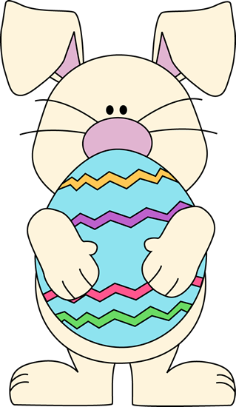
Happy Easter !!




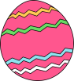
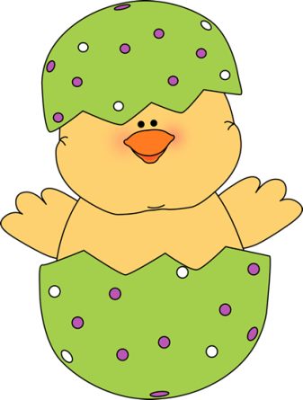
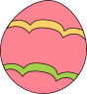
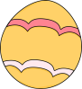

D N E C O P E T W E R Y O G Y
S J U V I Z S A H E N P N R A
V V T O E F P L T N L I V V R
J R Q L R X O S U Z R M P P A
Y K O B I B A B C P P L C K A
G Z J H L E R Q S H T I C R B
G C C H Y E J T Z M I L O A D
E V I P T A P E U L W C S B E
U M P S U F O Q L M Z K K B C
B A A M L L V P D L E T D I O
H E D Y E D E P X T Y S Q Y R
G A G W G Z P E L X P B I V A
P F U X J A C A B E B X E F T
R B P N V P K V T L J Y P A E
Y N N U B L S Z Q G T V R T N








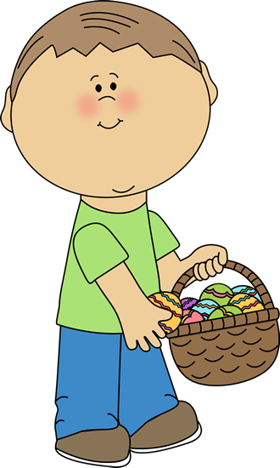


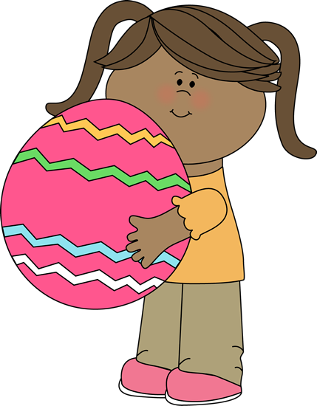





Solution

+ + + + + + + + + + R Y + G +
+ + + + + + + + + E N + N + +
+ + + + + + + + T N + I + + +
+ + + + + + + S U + R + + + +
+ + + + + + A B C P + + + + +
G + + + + E R + S H + + + + B
G + + + Y E J + + + I + + A D
E + + P T + + E + + + C S + E
+ + P S + + + + L + + K K + C
+ A A + + + + + + L E + + + O
H E D Y E + + + + T Y + + + R
+ + + + + + + + + + + B + + A
+ + + + + + + + + + + + E + T
+ + + + + + + + + + + + + A E
Y N N U B + + + + + + + + + N

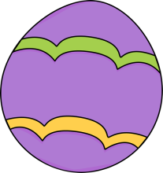
(Over,Down,Direction)
BASKET(15,6,SW)
BUNNY(5,15,W)
CHICK(9,5,SE)
DECORATE(15,7,S)
DYE(3,11,E)
EASTERBUNNY(2,11,NE)
EGG(1,8,N)
HAPPYEASTER(1,11,NE)
JELLYBEAN(7,7,SE)
SPRING(9,6,NE)
BASKET
BUNNY
CHICK
DECORATE
DYE
EASTERBUNNY
EGG
HAPPYEASTER
JELLYBEAN
SPRING

