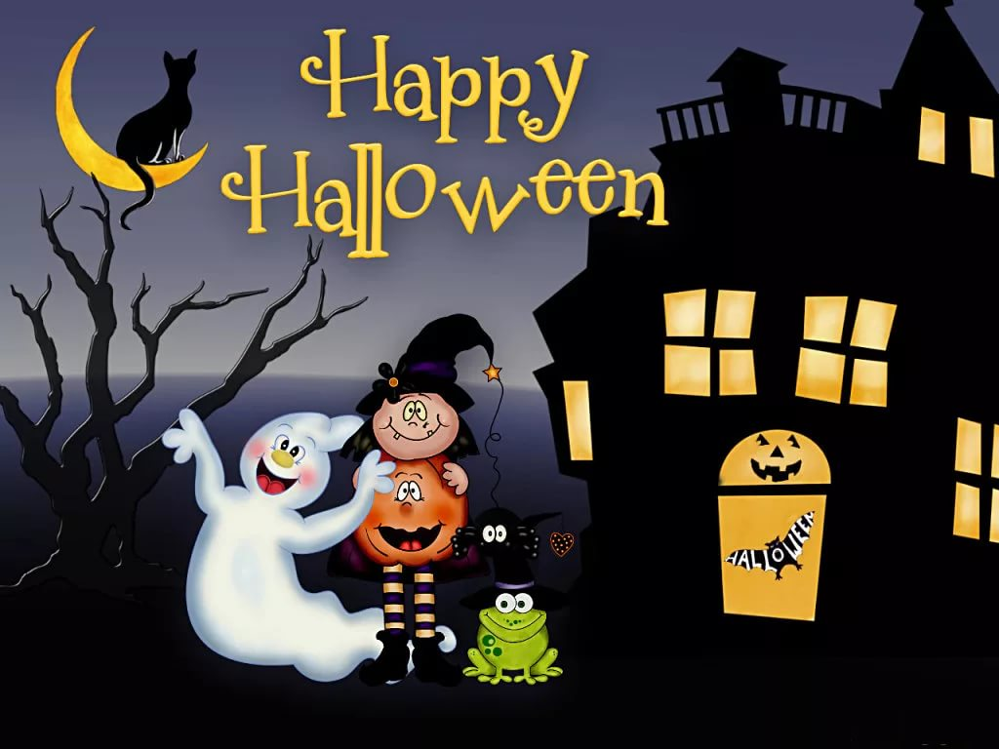

Halloween is celebrated every year on October 31st. The holiday is over 2000 years old. It started as a Celtic festival in Britain and Ireland, and then was introduced to North America byimmigrants from those countries. In recent years, the tradition has spread all around the world.
The ancient Celts believed that on the last day of October the spirits of the dead visited the living. Therefore, Halloween celebrations have always been connected with the theme of death and frightening creatures from the underworld.
Today, Halloween is celebrated by dressing up in scary costumes, listening to ghost stories and watching horror films. A lot of houses are decorated with jack-o’-lanterns, which are pumpkins carved like a terrifying face with a candle inside.
Children’s favourite Halloween activity is trick-or-treating. They knock on their neighbours’ doors and ask for sweets. If they do not get anything, they will play a trick on the person who opens the door.

