CHRISTMAS AROUND THE WORLD
BELGIUM  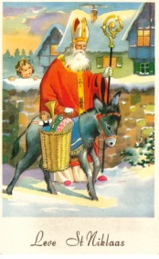  Belgian children there believe it is kindly Saint Nicholas who brings them their presents. They also believe he rides a horse so they leave him hay and carrots and water for the horse just outside the house on December 6. | CANADA / U.S.A.  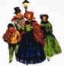  People decorate Christmas trees and hang their stockings on the fireplace for Santa Claus to fill with gifts. Cards and gifts are exchanged with friends and relatives. Children put on pageants and go carolling. | CHINA  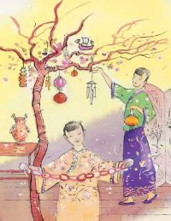  The Christians in China light their homes with beautiful paper lanterns. Santa is called Dun Che Lao Ren (Christmas Old Man). The children also hang stockings.
DENMARK  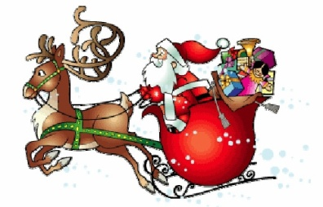  Santa is known as Julemanden and he arrives in a sleigh pulled by reindeer with a sack full of gifts. Danish children know the elves as Juul Nisse, and believe that they live in the attics of their homes. Instead of cookies and glasses of milk, they leave rice pudding and saucers of milk out for them. | FRANCE    Santa is known as Pere Noel. He is accompanied by Pre Fouettard who keep track of who has been good or bad. In some parts of France, Pere Noel brings small gifts in the beginning of December (Dec 6) and comes back to deliver more on Christmas. Children their shoes by the fire place to get gifts. People have dinner at midnight on December 24 this is called Le Réveillon, with a cake called La Buche de Noel. | ITALY  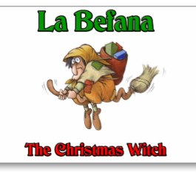  The main exchange of gift doesn't occur until January 6, the day traditionally believed that the Wise Men reached the baby Jesus. Italy has La Befana who brings gifts to for the good and punishment for the bad. She is the same character as Russia's Babouschka who refused to give the Wise Men food and shelter. The nativity scene may have first been set up by Saint Francis of Assisi.
INDIA  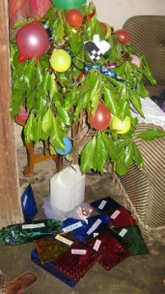  Houses are decorated with strings of mango leaves. Lights are placed on the window and walls and people hang a star outside. A sweet holiday treat is made called thali and it is brought to neighbours and friends. | JAPAN  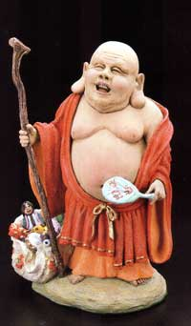  The Japanese decorate their stores and homes with greens. The only part of Christmas that they celebrate is the giving of gifts. Hoteiosha, the priest is like our Santa Claus, and he brings the children their presents. | MEXICO  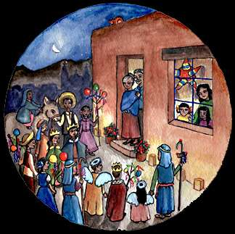  They celebrate Christmas for nine days with Las Pastorelas. It is a time where people dress as Mary and Joseph, traveling from house to house asking if Mary may stay the night. Then, they are invited in for a party with food, songs, and for children a Piñata filled with all kinds of goodies.
THE NETHERLANDS  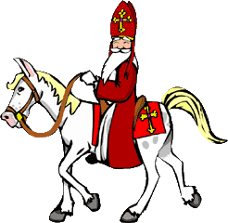  Santa is known as Sinterklaas. He makes his gift deliveries by horseback. Children leave their shoes out, filled with hay and sugar for Sinterklaas' horse. In the morning they find their shoes filled with candy and nuts. When Sinterklaas appears to the children, he takes the form of their father or a favourite male relative. | SPAIN  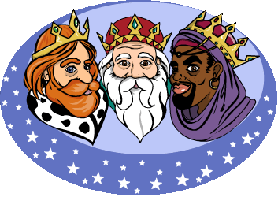  Spanish children of Spain leave their shoes filled with straw and barley for the camels of the Wise Men, who re-enact their journey to Bethlehem every year. They call Christmas Eve Nochebuena, and families gather together to rejoice and share a meal around the Nativity scene. | UK  Boxing Day is celebrated the first weekday after Christmas, when small wrapped boxes with food and sweets, or small gifts are given to anyone who comes that day.  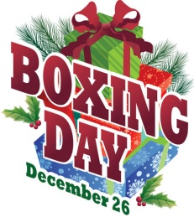  The tradition of hanging stockings by the chimney began here because Father Christmas once accidentally dropped some gold coins on his way down the chimney which got caught in a drying stocking. British children wait until the afternoon to open their gifts.
1. Christians in China call Santa Claus Dun Che Lao Ren, which means…
2. In Mexico, the pastorelas are…
3. The first nativity scene was displayed in 1223 by St. Francis of Assisi. In which country?
4. In which country is a log-shaped cake called a "Bûche de Noel" traditionally served?
5. Boxing Day is celebrated in which country?

Answer key
http://www.portharbor.com/santa/xsatrad.htm
- Christmas old man
- Mexicans reenact Mary and Joseph's search for lodging
- Italy
- France
- United Kingdom

