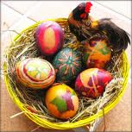 Easter in England
Easter it is a time for the giving and receiving of presents which traditionally take the form of an Easter egg and hot cross buns. The Easter egg is by far the most popular emblem of Easter, but fluffy little chicks, baby rabbits and spring time flowers like daffodils, dangling catkins and the arum lily are also used to signify the Nature's awakening.
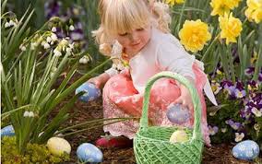
Nowadays Easter eggs are usually made of chocolate or marzipan or sugar. True Easter eggs are hard-boiled, dyed in bright colours, and sometimes elaborately decorated. Colouring and decorating the festival eggs seems to have been customary since time immemorial They can be dipped into a prepared dye or, more usually, boiled in it, or they may be boiled inside a covering of onion peel Natural dyes are often used for coloring today. They are obtained from flowers, leaves, mosses, bark, and wood-chips.
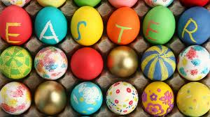
Egg-rolling is a traditional Easter pastime which still flourishes in Britain. It takes place on Easter Sunday or Monday, and consists of rolling coloured, hard-boiled eggs down a slope until they are cracked and broken after which they are eaten by their owners. In some districts this is a competitive game. But originally egg-rolling provided an opportunity for divination. Each player marked his or her egg with an identifying sign and then watched to see how it sped down the slope. If it reached the bottom unscathed, the owner could expect good luck in the future, but if it was broken, unfortune would follow before the year was out, Eating hot cross buns at breakfast on Good Friday morning is a custom which is also flourishing in most English households. Formerly, these round, cakes marked with a cross, eaten hot, were made by housewives who rose at dawn; for the purpose, or by local bakers who worked through the night to have them ready for delivery to their customers in time for breakfast. There is an old belief that the true Good Friday bun — that is, one made on the anniversary itself — never goes moldy, if kept in a dry place. It was once also supposed to have curative powers, especially for ailments like dysentery, diarrhea, whooping cough, and the complaint known as "summer sickness". Within living memory, it was still quite usual in country districts for a few buns to be hung from the kitchen ceiling until, they are needed. When illness came the bun was finely grated and mixed with milk or water, to make a medicine, which the patient drank. 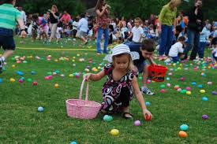
Task 1. Name the word shown on the picture.
1.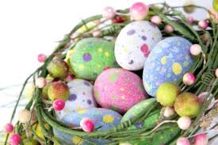
2. 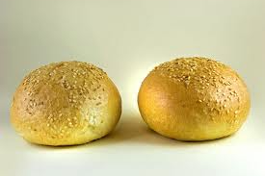
3. 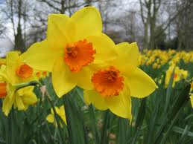
4. 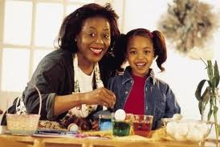
5. 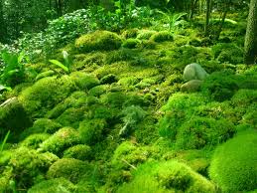
Task 2. Sing a song.
Easter Bunny
Looking kind of funny
With your basket of eggs
Children singing
'What's the bunny bringing
For me on Easter Day?"

Mom is cooking
While we're out there looking
For the eggs hidden away
After church we
Gathered 'round with family
On this Easter Day

Two thousand years ago
Jesus died for our sins
Remember his resurrection
And the joy it brings

Flowers blooming
Springtime's looming
Everything is coming alive
Easter colors
Yellow, blue and others
Tell us Spring has arrived

Children are playing
And everybody's saying
"So good to see you today!"
We're all together
The merrier the better
On this Easter holiday

Two thousand years ago
Jesus died for our sins
Remember his resurrection
And the joy it brings

Flowers are blooming
& Springtime's looming
Oh what a wonderful day
We're all together
The more of us the better
On this Easter holiday
A lovely Easter holiday
I like my Easter holiday

Written by Wendy Wiseman
http://www.youtube.com/watch?v=2_W-jAuzUhY – link for a song
Task 3. Answer the questions.
- When do people celebrate Easter?
- Do you like this holiday? Why/why not?
- When do people celebrate Easter in your country?
- What is your favorite holiday?
- What do you like most of all abut Easter?

